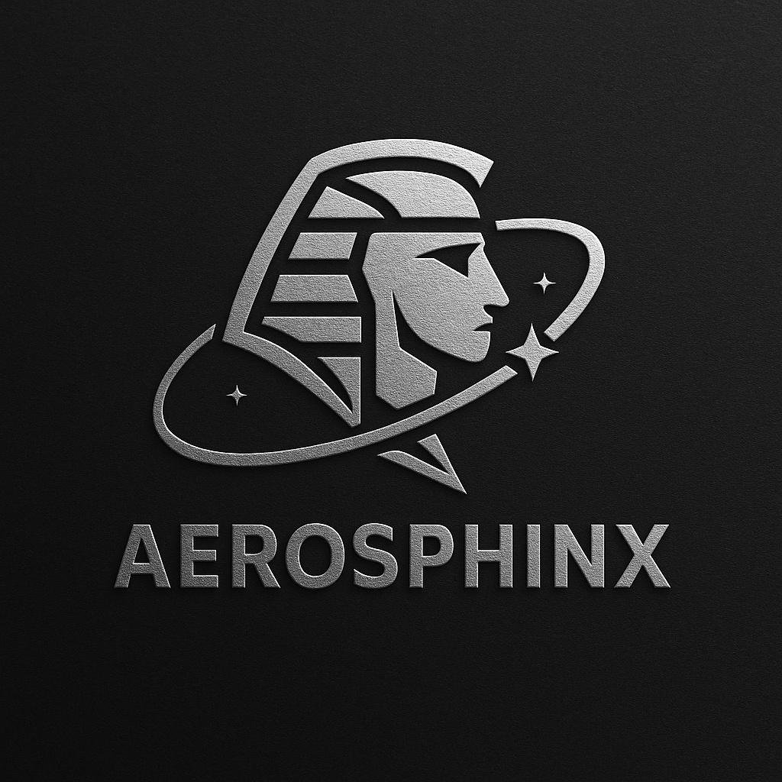
Basic Research (Indraneel Chatterjee)

Problem: Air pollution remains a severe public health and environmental challenge. Despite the availability of satellite data and ground sensors, there is a lack of unified systems that can analyze, forecast, and visualize pollution in real-time. This challenge demands a solution that combines satellite imagery, ground-level data, and AI/ML to provide actionable insights and early alerts.
Solution: PawanAI is a real-time, AI-powered platform that estimates and forecasts surface-level PM2.5 pollution using three key data streams:
AOD (Aerosol Optical Depth) from INSAT-3D/3DR/3DS satellites
Ground-level PM2.5 data from CPCB/OpenAQ
Atmospheric reanalysis variables (e.g., BLH, temp, wind) from MERRA-2
It uses ML models (Random Forest/XGBoost) to predict high-resolution pollution maps across India, 2–3 hours in advance, even in regions without physical air sensors.

Data Sources:
- AOD Data → INSAT-3D/3DR/3DS (via MOSDAC/ISRO archives)
- Ground PM Data → CPCB station-level datasets (via OpenAQ or direct CSV)
- Reanalysis Data → MERRA-2 variables (temp, wind speed, humidity)
Processing Pipeline:
- Preprocessing
  - Normalize spatial resolution between AOD and CPCB datasets
  - Interpolate missing values
  - Merge datasets using spatial-temporal alignment
- Model Development
  - Train an ML regression model (Random Forest (preferred) or XGBoost)
  - Input: It will need three following inputs:
      - Current & lagged AOD (t, t–1, t–2)
      - Reanalysis vars (wind, humidity, temp)
      - Hourly trends from CPCB data
  - Output: PM2.5 estimates
- Prediction & Validation
  - Predict current and future(2-3 hours) surface PM values pan-India
  - Validate predictions with C-PCB values (MAE, RMSE)
- Visualization
  - Render high-resolution pollution heatmaps with colour coding
  - Optionally add a web-based dashboard (Streamlit/Folium)
  - Alarm System for unpure Air

Difficult Task: Instead of just raw AOD, include:
- AOD Gradient (spatial slope): shows if pollution is moving in
- Wind Direction Vectors: helps anticipate drift
- Humidity × AOD interaction: better PM behaviour modelling
- Lag-based temporal features: from last 3–6 hours of CPCB + reanalysis data
➡️ This drastically improves model accuracy & dynamic behaviour.
